|  |  |  |
| --- | --- | --- |
| Report on Wealth of Nations | May 17  2024 | |
| A. Data visualization to help transform information into insights on data from the nation’s GDP, Life expectant at birth and Smart phone users. Objective of the data is to drive meaningful business outcomes and improved experiences. | | Bilqis Lawal |

# Table of Content

Front page1

**Table of Content2**

**Introduction3**

Policies and procedures 3

Data Protection and Compliance3

Compliance with computer misuse3

**Data Familiarization**3

**Data Preparation and cleaning – data cleaning and transformation** 4-9

**Visualization and Analysis in Tableau**9-12

**Conclusion**12

**Reflections**12

1. **Introduction**

The purpose of the report is to provide a data visualization to help transform information into insights that can drive meaningful business outcomes and improved experiences. It will also ultimately drive an informed decision making process.

1. **Policies and Procedures**

* **Data Protection and Compliance**

Data protection is of paramount importance for organizations to safeguard sensitive information, comply with regulations, prevent data breaches, build trust with stakeholders, and ensure business continuity and to uphold ethical standards in data handling practices. By prioritizing data protection, our organization can mitigate risks and create a secure environment for data-driven decision-making and innovation.

* **Compliance with computer misuse**

Compliance with computer misuse policies is critical for safeguarding the organisation’s information systems, protecting sensitive data, maintaining operational continuity, and preserving the organisation’s reputation. It encompasses guidelines for handling sensitive information, ensuring it is accessed and used only by authorised personnel. The policy also set guidelines for secure usage of systems, helping to prevent incidents like data breaches, malware attacks, and insider threats.

1. **Data Familiarization**

The first step involved in familiarising the provided data workbook(spreadsheet) which are dates, countries, ranks and year of information. Key areas of focus includes

1. Gross Domestic Product (GDP) in the nation

This is a monetary measure of the market value of all the final goods and services produced within a country’s borders in a specific time period.

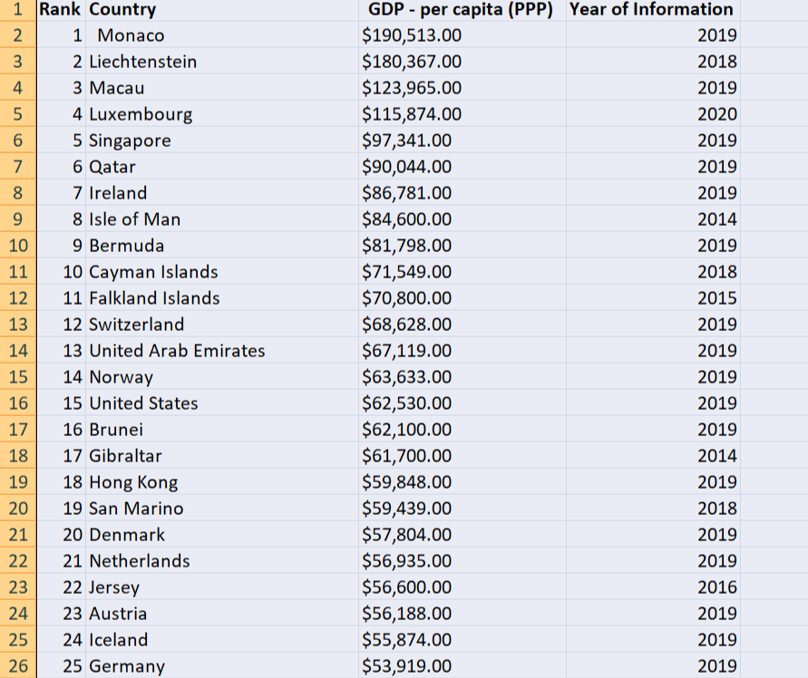

1. Life Expectant at Birth in the nation

This is the statistical measure of the estimate of the average remaining years of life at a given age.

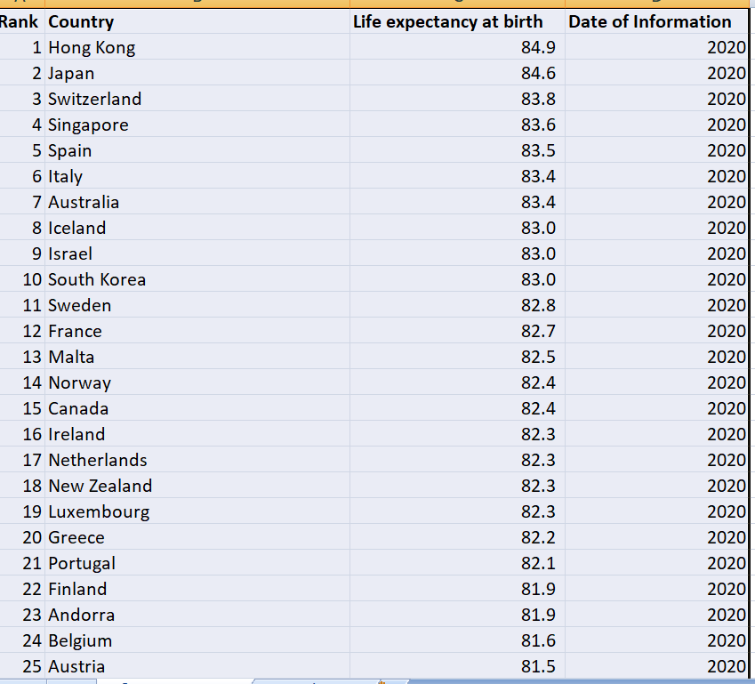

1. Smartphone users in the Nation

This forecasts the global number of Smartphone users in the nation

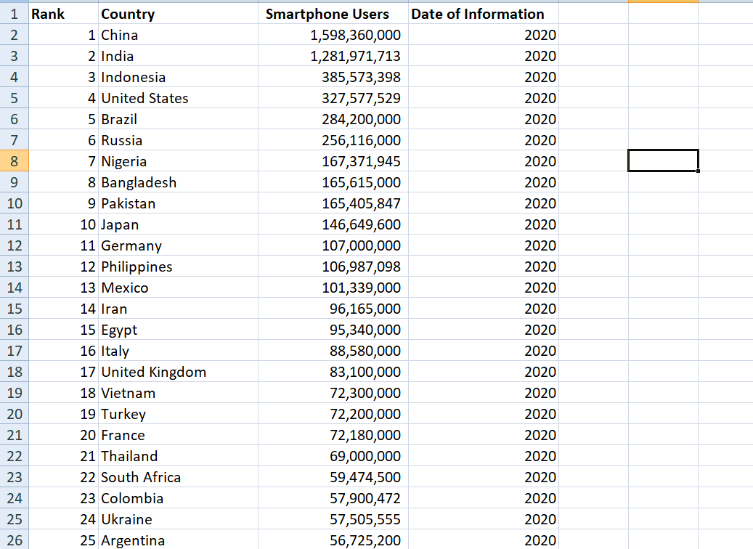

1. **Data Preparation and cleaning – data cleaning and transformation.**

* **Setting a password**

First step taken was setting up a password on the workbook by first highlighting the workbook and clicking on the Tab – “**Review**” as shown below. Next step is clicking on the “**protect workbook”** which pops up a display box with list of options of all the areas on the workbook and a space to type a password as shown below. In this case as password was inputed **“1982**”

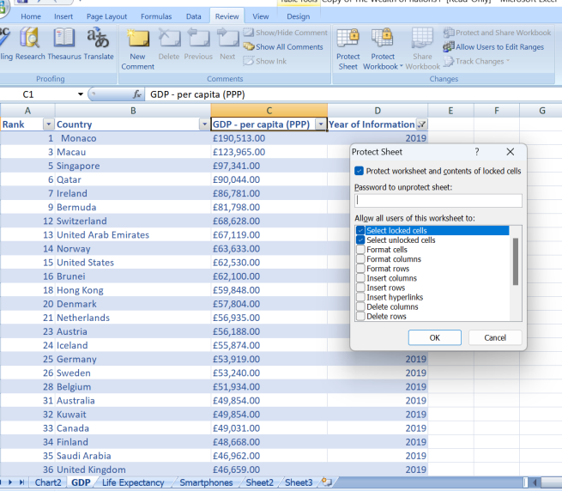

* **Changing the data to display a British pound sterling symbol**.

First step taken was highlighting the column “**C”,** next step is clicking in the **“Home”** Tab which displays the currency where an option to choose from a drop list the required currency, in this case the “**£”** symbol as shown in the diagram below.

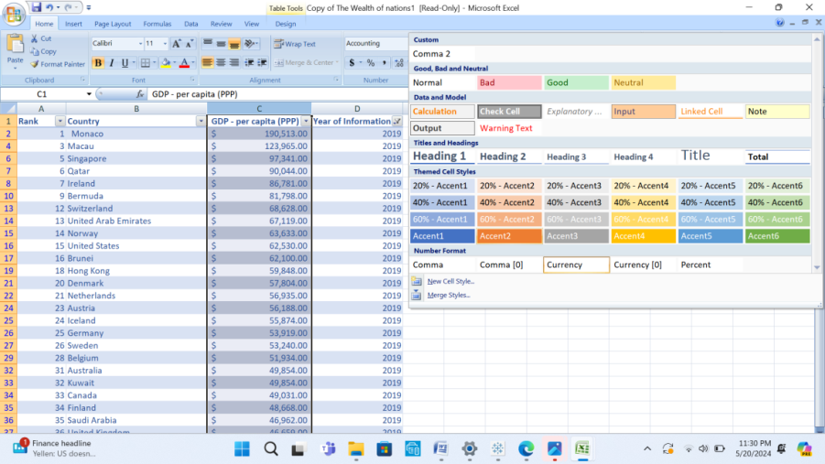

* **Turning the GDP sheet into a table**

The required sheet of information was highlighted, next step is clicking on the “**Home”** tab and picking the “**Format as table”** which displays different formatting styles to choose from. In this case, the light option was selected.

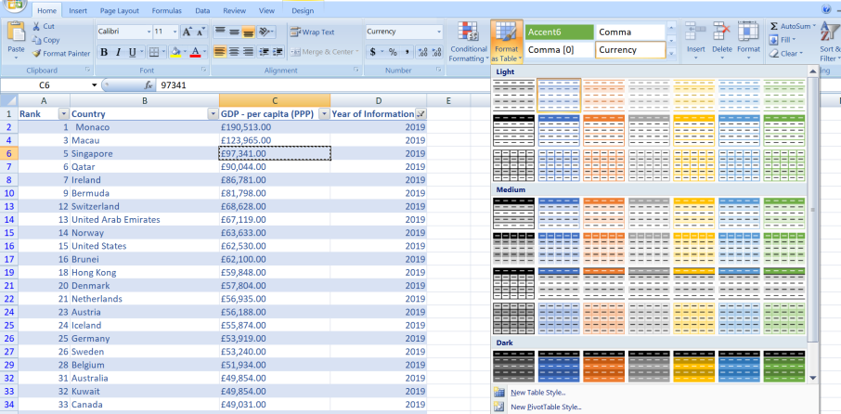

* Data filtering to show information from the year 2019

Required sheet was highlighter, next step is clicking the drop down button on the **year of information**, which displays a list of years to choose. In this case only “**2019”** was ticked. This then displays only information from **“2019”**

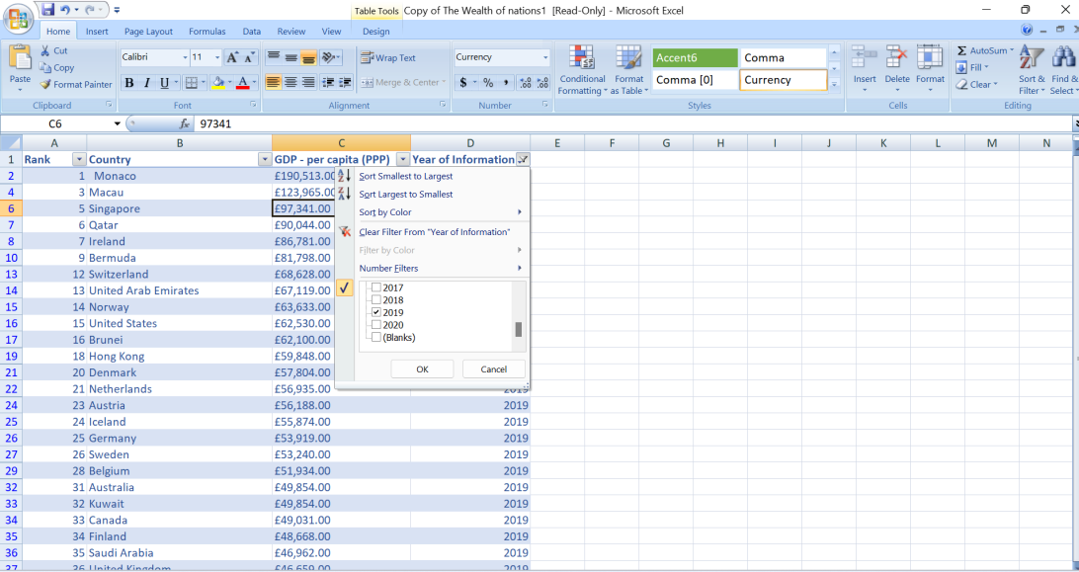

* **Creating a chart in Excel**

First step was highlighting the area on the excel sheet, next step is to click on the **“Insert”** Tab which displays a set suitable charts.

Labeling X,Y axis and the chart. First step is to highlight the chat, click on the “layout” tab and choose option(s) **“chart table**” and “**Axis tables**” under the ribbons respectfully as displayed below.

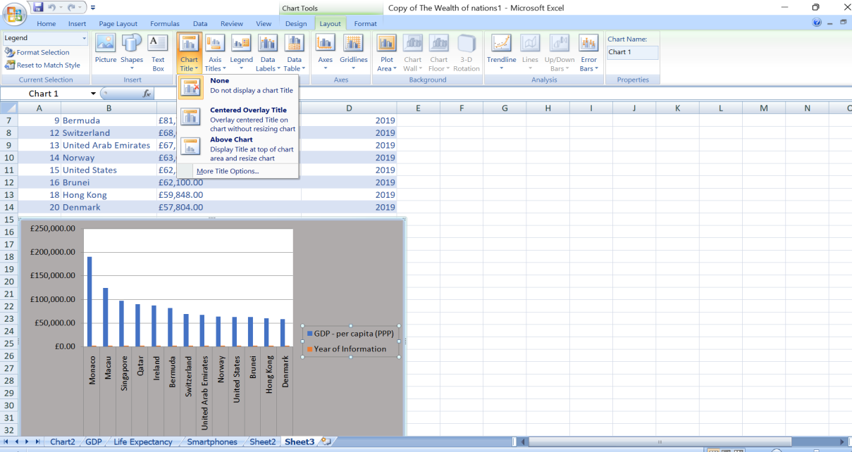

* **Moving the chart to a new sheet and labeling it.**

First step, chart copied and pasted on a new sheet. New sheet is found on the bottom tool bar. To label, right click and click on rename. Sheet labeled 2019chart.

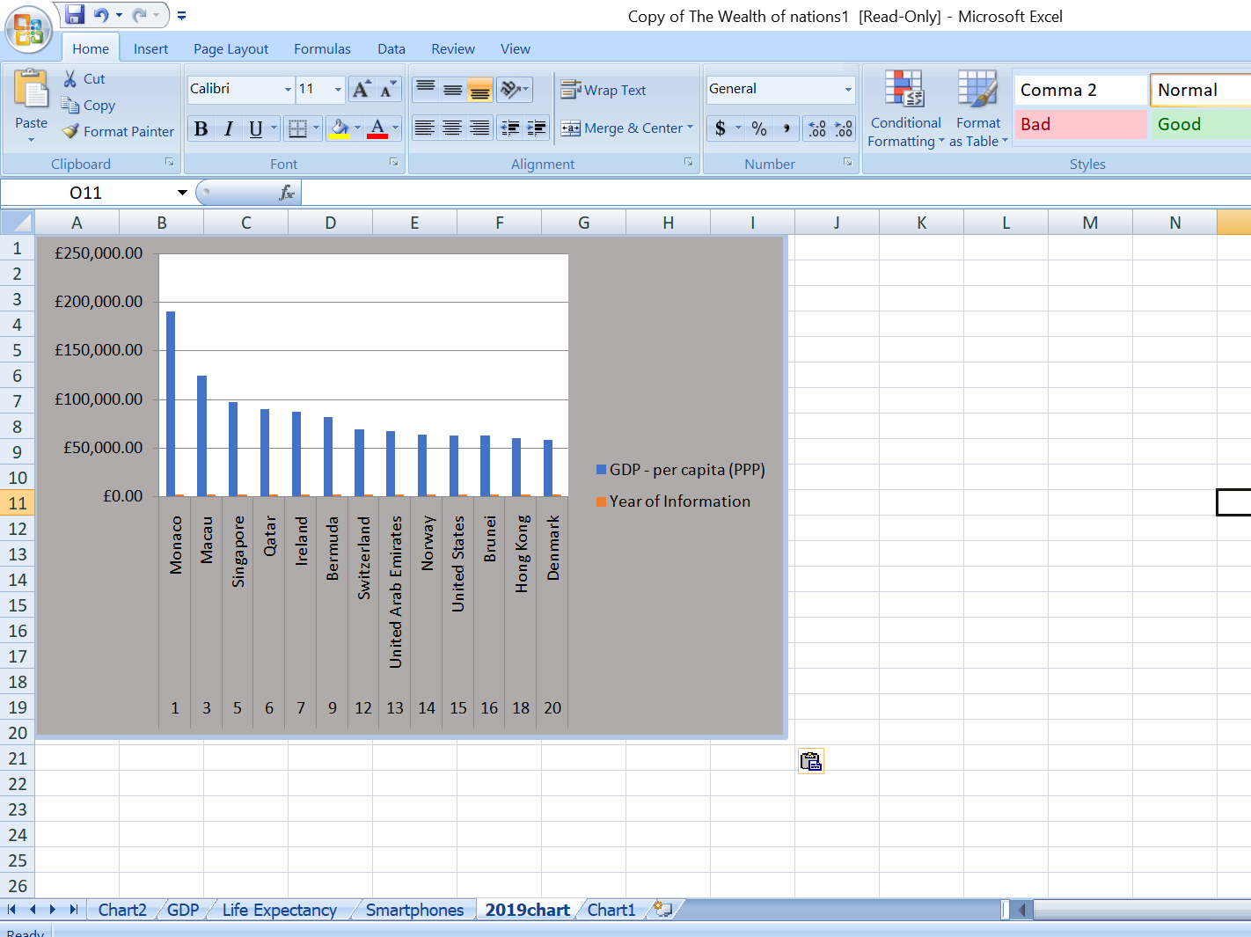

* **Creating and sorting the highest ranking countries**

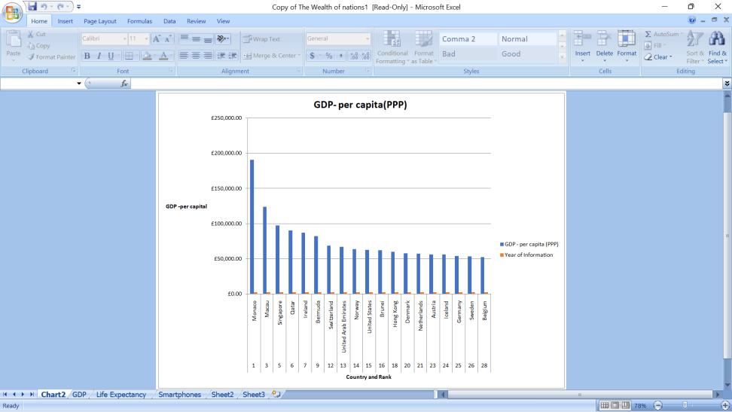

1. **Visualization and Analysis in Tableau**

First step, attaching excel document to excel spread sheet on Tableau data source. Next time inserting a range of information to process which is top 20 countries by rank. Thirdly creating individual graphs for each data.

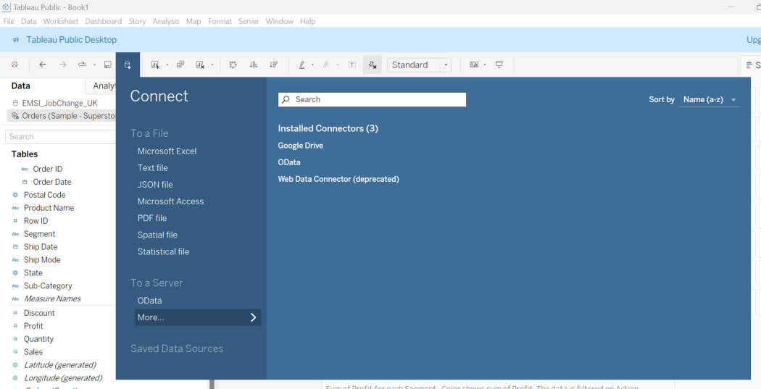

* Description of the visualizations created using Tableau.

Dragging information (GDP, Life expectancy and Smartphone users) extracted into tableau by the left into the middle for data processing

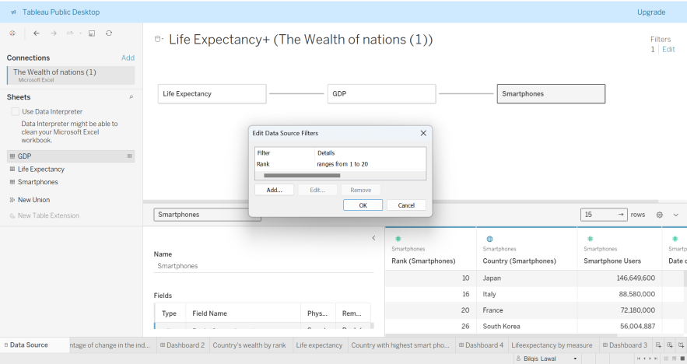

* Breakdown of the dashboards and the specific charts and maps included in each.
* Gross Domestic Product (GDP) in the nation. Chart displaying countries wealth according to their rank. Greece is ranked the highest in terms of (GDP).

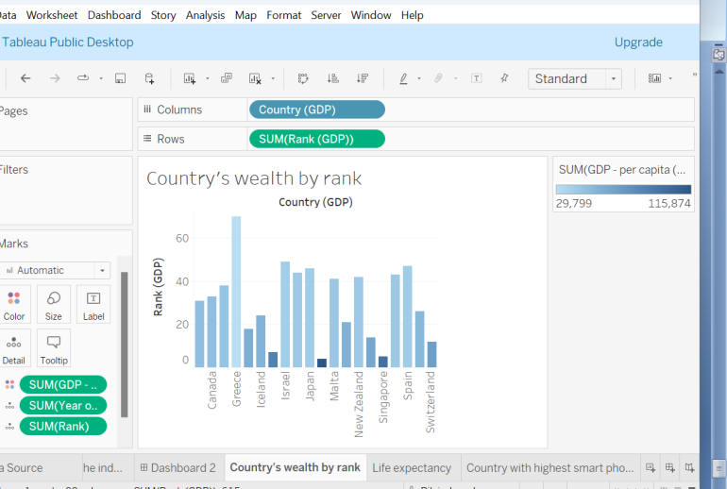

* Life Expectant at Birth in the nation based on the country, date of information. Count of life expectant and rank.

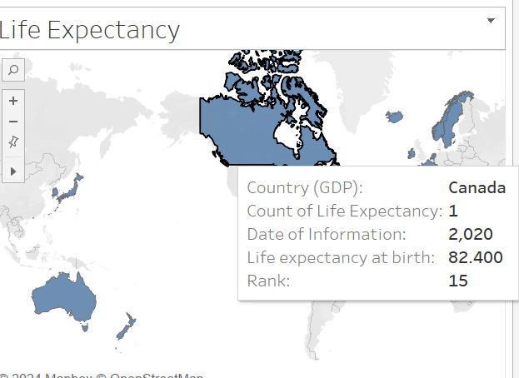

* Smartphone users

In the graph below, Japan is the country with the highest use of smart phones.

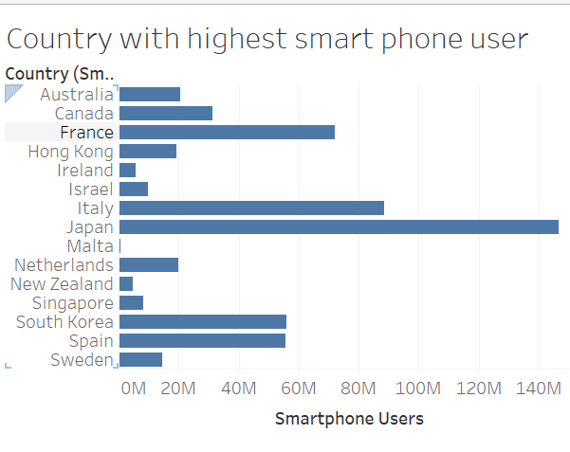

* Life expectant at birth by measure. Hong Kong is the highest with a sum of life expectant at birth at 84 900

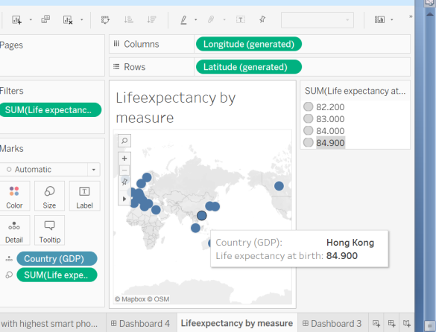

* Dashboard

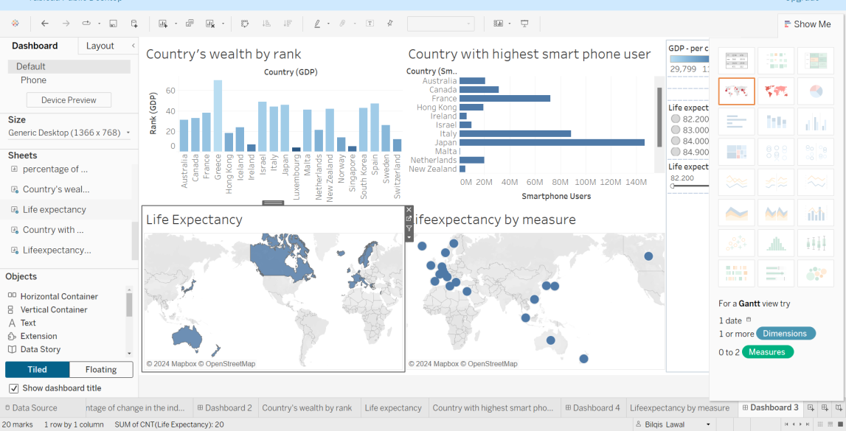

1. **Conclusion**
2. **Summary of the findings**